
www.globalsight.com

GlobalSight Function Design

Summary: Dispatcher Middleware

Bug ID: GBS-3410

Fixed Version: 8.5.3

Author : Joey Jiang

Contents
Background & Requirement 3
Terms 3
Discussion 3
Function Design 4
Processing Logic 4
Permission 5
UI Design 6
Inputs and Outputs 9
Difficulties 9

Date | Description | Version | Author
2014-02-11 | Initial document | 0.1 | Joey Jiang
2014-04-03 | Do some modifications | 0.2 | Joey Jiang

Background & Requirement

DispatcherMW (Middleware) is an adapter of Machine Translations, which supply a general Service for many Machine Translation Services.

How to use DispatcherMW for Machine Translation?
The customer upload a XLIFF file to DispatcherMW firstly, then DispatcherMW will do translation and prepare translated XLIFF file to customer.

Terms

Add description of all necessary terms here to help user understand your design clearly.

The following terms are used throughout this document:

- Machine Translation – A sub-field of computational linguistics that investigates the use of software to translate text or speech from one natural language to another.
- XLIFF (XML Localization Interchange File Format) - An XML based format created to standardize the way localizable data are passed between tools during a localization process.

Discussion

- How to support multiple customers in DispatcherMW?
Now, the DispatcherMW use source language, target language and security code to detect the MT Profile, which is used for MT.

- The DispatcherMW should support the XLF file contained multiple <file> tag.
This requirement could be fixed in future.

Function Design

Processing Logic

DispatcherMW support a function for translating XLF file with MT.
The Process of translate XLF file is:
Step | Function Description | XLIFF File Description
Step 1 | Upload XLF file.  The DispatcherMW will return jobID for next process. | The XLF file contain source locale, target locale and source segments.  The security code comes from configure file.
Step 2 | Check Translate Status.
Step 3 | Download XLF file. | The XLF file contains target segments.

The URL of translate XLF file:
Step | Function Description | URL
Step 1 | Upload XLF file. | http://localhost:8888/dispatcherMW/translateXLF/upload/?securityCode={ securityCode }
Step 2 | Check Translate Status. | http://localhost:8888/dispatcherMW/translateXLF/checkStatus/?jobID={jobID}
Step 3 | Download XLF file. | http://localhost:8888/dispatcherMW/translateXLF/download/?jobID={jobID}& securityCode ={ securityCode }

Useful URL
Name | URL | Description
getLanguages  ByAccountName | http://localhost:8888/dispatcherMW/translateXLF/  getLanguagesByAccountName?accountName={ accountName } | Display all language info by account name.
getAccount | http://localhost:8888/dispatcherMW/translateXLF/  getAccount? securityCode ={ securityCode } | Display Account info by security code

The statuses for Step2 are: “queued”, “running”, “completed”, and “failed”.

The description for saved information in DispatcherMW:
File Type | File Path
MT Profile Info | DispatcherMW/data/MachineTranslationProfiles.xml
Account Info | DispatcherMW/data/Account.xml
Language Info | DispatcherMW/data/Languages.xml
Uploaded XLF file | DispatcherMW/fileStorage/{AccountName}/{Job ID}/source/*.xlf
Translated XLF file | DispatcherMW/fileStorage/{AccountName}/{Job ID}/target/*.xlf

Permission

The default credential is superAdmin/password, which is configured in
conf/tomcat-users.xml.
See more details in below:
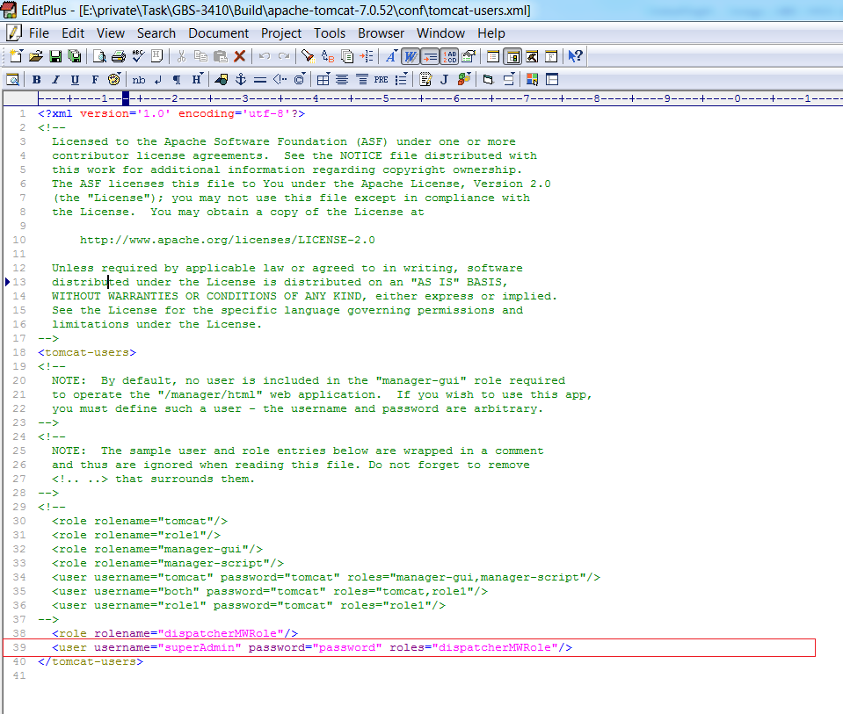

UI Design
The UI for Home Tab.
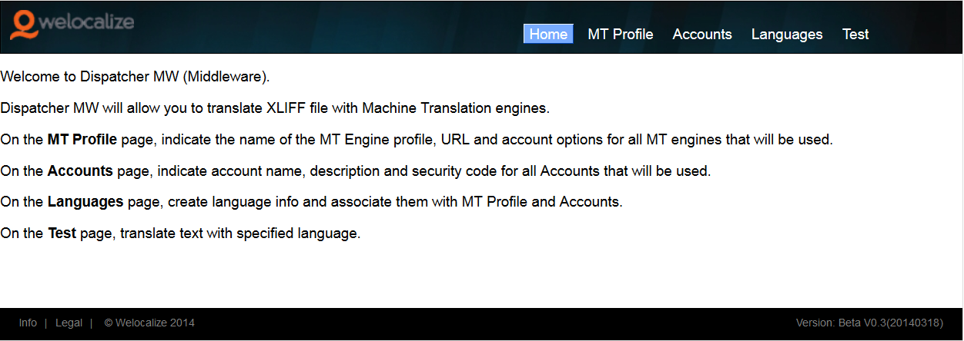

The UI for MT Profile Tab.
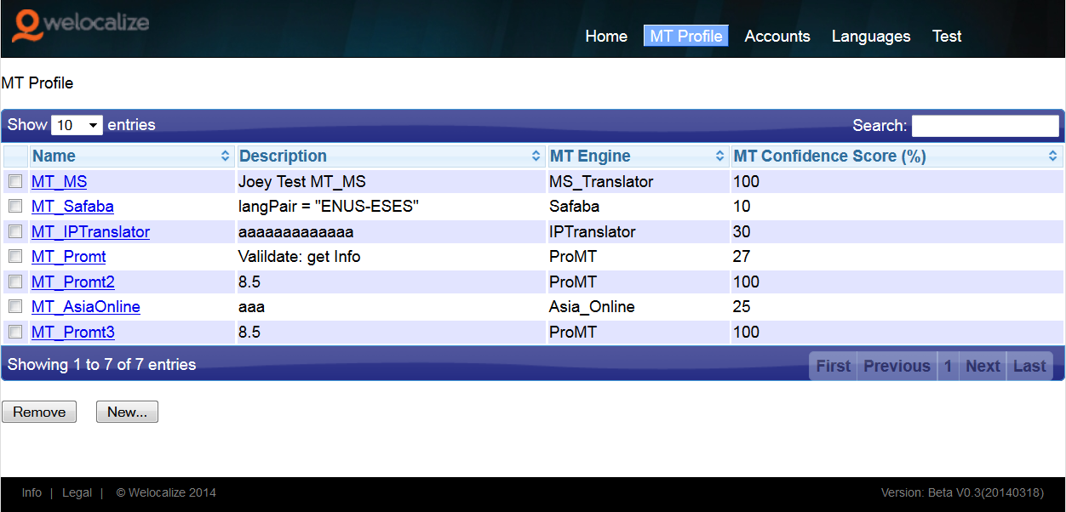

The UI for Accounts Tab.
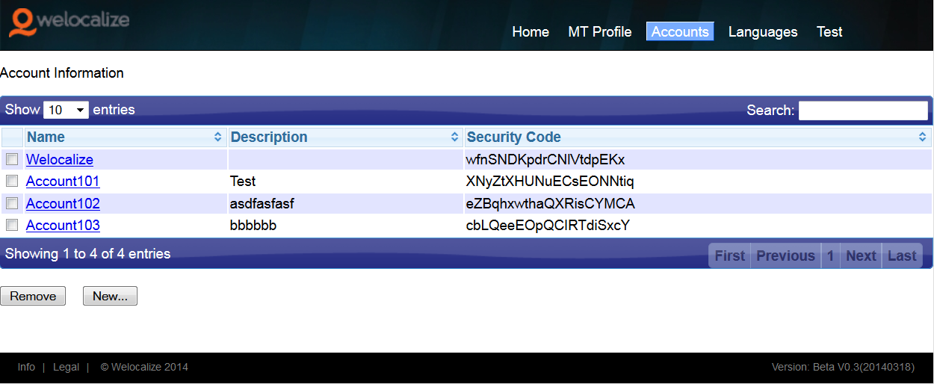

The UI for Languages Tab.
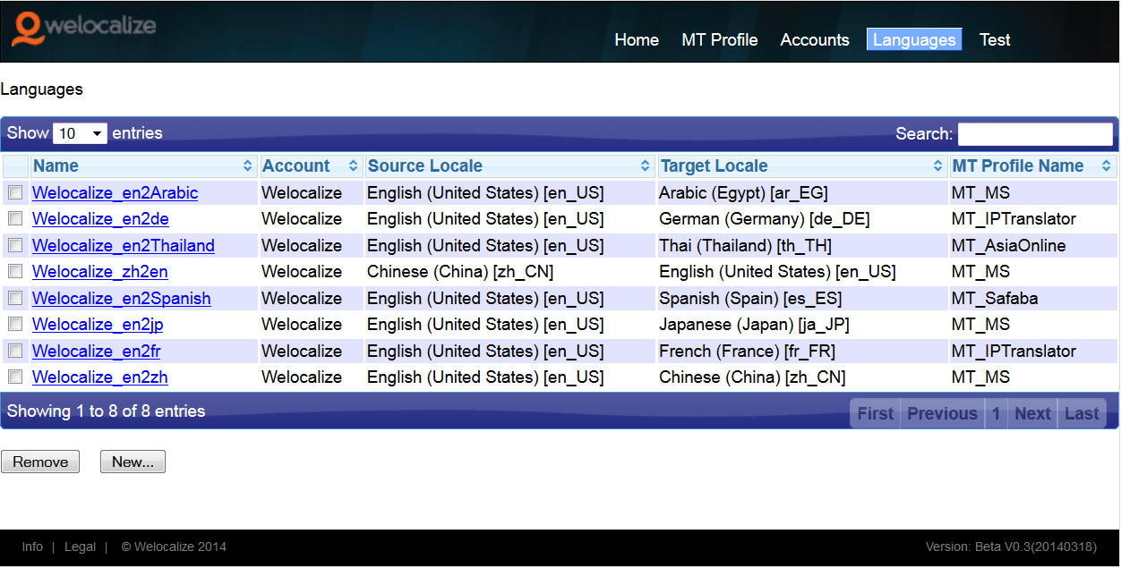

The UI for Test Tab.
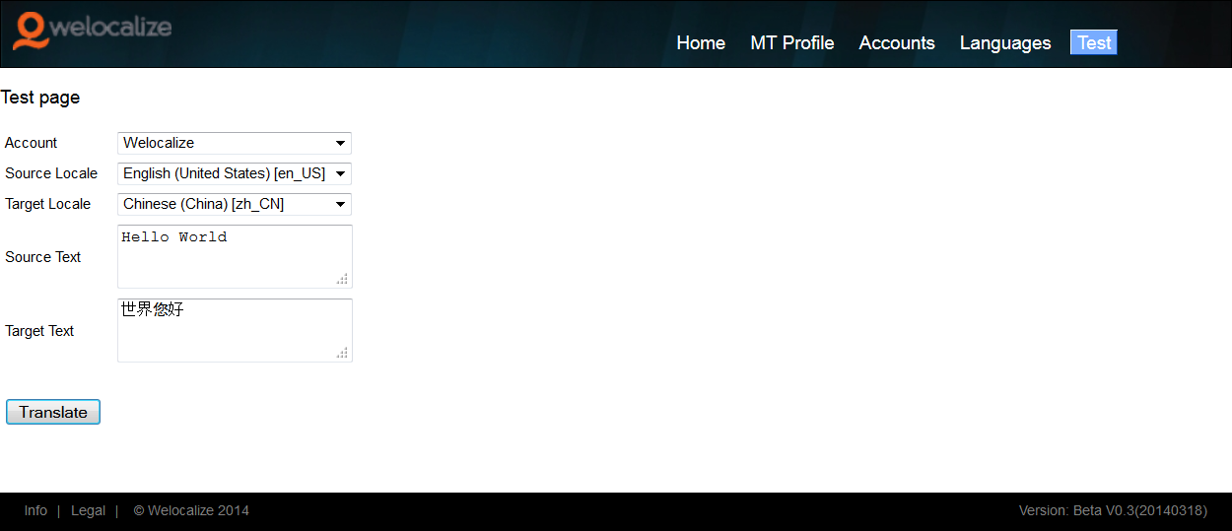

Inputs and Outputs

The XLF file for upload:
<?xml version="1.0" encoding="UTF-8"?>
<xliff version="1.2">
<file client-code="Welocalize" source-language="en-US" target-language="zh-CN">
<header>
</header>
<body>
<trans-unit>
<source>Hello World.</source>
<target></target>
</trans-unit>
<trans-unit>
<source>Welcomet to China!</source>
<target></target>
</trans-unit>
</body>
</file>
</xliff>

The XLF file for download:
<?xml version="1.0" encoding="UTF-8"?>
<xliff version="1.2">
<file clientCode="Welocalize" source-language="en-US" target-language="zh-CN">
<header>
</header>
<body>
<trans-unit>
<source>Hello World.</source>
<target>你好世界</target>
</trans-unit>
<trans-unit>
<source>Welcomet to China!</source>
<target>欢迎来中国！</target>
</trans-unit>
</body>
</file>
</xliff>

Difficulties
Upload XLF file and download.

